https://www.aerafoundation.org/
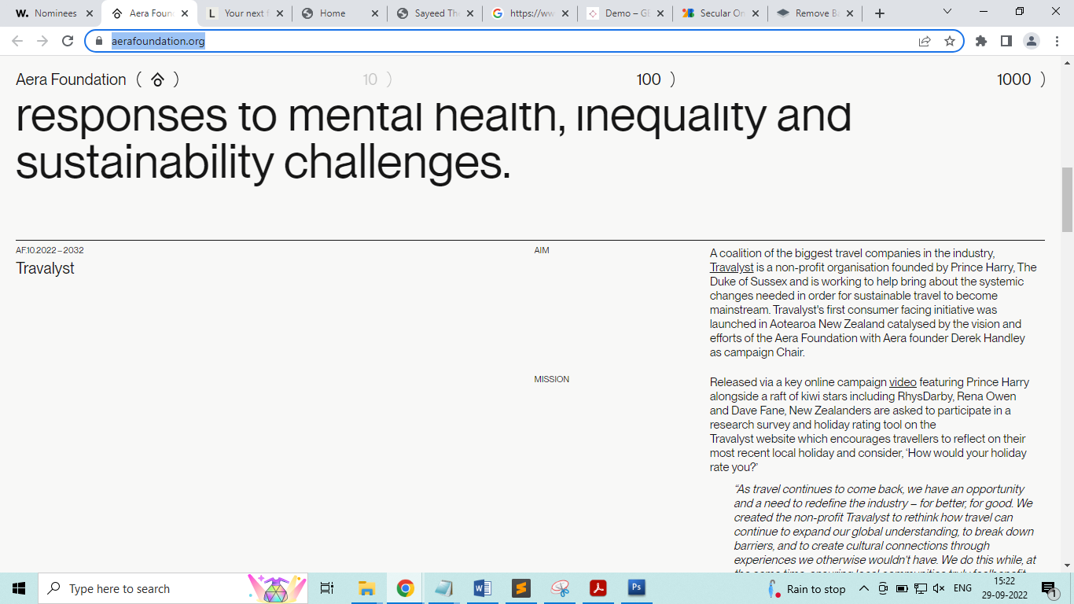
----------------.
https://luukthe.dev/
